CMPT 762

Computer Vision

Assignment 4

Gokul Mohanarangan

gma56@sfu.ca

301436162

**4.1 Show matched features**



4.2 Visualization of 3 samples using BRIEF







Histogram for BRIEF :



Visualization of 3 samples using SURF:







Histogram for SURF:



**Why does the BRIEF behave this way ?**

BRIEF does not seem to be rotation invariant i.e.) even small rotations highly impact the performance. This is because BRIEF is a binary descriptor and describes the feature points as a binary string depending on the ordering of the pixel intensities of the local image patch. During rotation, the ordering of the pixel in the local image patch changes abruptly depending on the angle of rotation and due to this, the calculated feature descriptor binary string also vastly differs. Hence, when using BRIEF, when the image is rotated, it is no longer capable of matching feature points based on the generated binary descriptor strings alone and as a result, the performance of matching the image suffers greatly.

**Does the plot change significantly ?**

When I replace the BRIEF with SURF, the plot changes significantly. The SURF detector and descriptor works very well even if the images are rotated with an angle whereas BRIEF performs poorly if the input image is even slightly rotated. We can see that clearly using the histograms that, with rotations, the matched points falls significantly and only gets slightly better when it is again close to the original image in BRIEF. Whereas the matched points for SURF is very good in spite of image rotations and has multi-modal plot curve in the histogram. Evidently, SURF is better at feature descriptions than BRIEF from the experiment.

4.3 Homography computation

4.4 Homography normalization



4.5 RANSAC



4.6 Harry Potterize a book

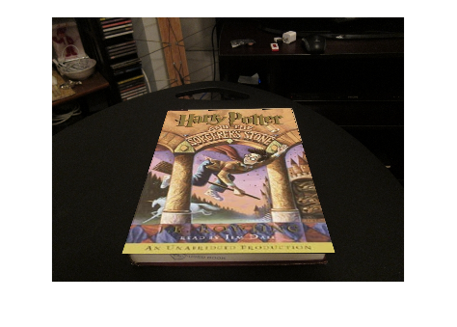

6 ar.avi uploaded to Canvas submission